1-

|  |  |  |  |
| --- | --- | --- | --- |
|  | E21 | E22 | E23 |
| E11 | -13, -8 | -1, -4 | 7, -4 |
| E12 | -4, -1 | 4, -1 | 4, -4 |
| E13 | 1, 2 | 1, -1 | 1, -4 |

A coluna E22 domina a coluna E23

|  |  |  |  |
| --- | --- | --- | --- |
|  | E21 | E22 | E23 |
| E11 | -13, -8 | -1, -4 | 7, -4 |
| E12 | -4, -1 | 4, -1 | 4, -4 |
| E13 | 1, 2 | 1, -1 | 1, -4 |

A linha E13 domina a linha E11

|  |  |  |
| --- | --- | --- |
|  | E21 | E22 |
| E11 | -13, -8 | -1, -4 |
| E12 | -4, -1 | 4, -1 |
| E13 | 1, 2 | 1, -1 |

A coluna E21 domina E22

|  |  |  |
| --- | --- | --- |
|  | E21 | E22 |
| E12 | -4, -1 | 4, -1 |
| E13 | 1, 2 | 1, -1 |

A linha E13 domina E12

|  |  |
| --- | --- |
|  | E21 |
| E12 | -4, -1 |
| E13 | 1, 2 |

|  |  |
| --- | --- |
|  | E21 |
| E13 | 1, 2 |

2-

|  |  |  |  |
| --- | --- | --- | --- |
| P1/P2 | E21 | E22 | E33 |
| E11 | 1,**2** | 2,**2** | 5,1 |
| E12 | 4,1 | 3,**5** | 3,3 |
| E13 | **5**,2 | **4**,**4** | **7**,0 |
| E14 | 2,3 | 0,**4** | 3,0 |

3-

|  |  |  |  |  |  |  |
| --- | --- | --- | --- | --- | --- | --- |
|  | 0 | 20 | 40 | 60 | 80 | 100 |
| 0 | 0, 0 | 0, 20 | 0, 40 | 0, 60 | 0, 80 | 0, 0 |
| 20 | 20, 0 | 20, 20 | 20, 40 | 20, 60 | 20, 80 | 0, 0 |
| 40 | 40, 0 | 40, 20 | 40, 40 | 40, 60 | 0, 0 | 0, 0 |
| 60 | 60, 0 | 60, 20 | 60, 40 | 0, 0 | 0, 0 | 0, 0 |
| 80 | 80, 0 | 80, 20 | 0, 0 | 0, 0 | 0, 0 | 0, 0 |
| 100 | 100, 0 | 0, 0 | 0, 0 | 0, 0 | 0, 0 | 0, 0 |

A coluna 20 domina a coluna 0.

A a linha 20 domina as linha 0.

|  |  |  |  |  |  |  |
| --- | --- | --- | --- | --- | --- | --- |
|  | 0 | 20 | 40 | 60 | 80 | 100 |
| 0 | 0, 0 | 0, 20 | 0, 40 | 0, 60 | 0, 80 | 0, 0 |
| 20 | 20, 0 | 20, 20 | 20, 40 | 20, 60 | 20, 80 | 0, 0 |
| 40 | 40, 0 | 40, 20 | 40, 40 | 40, 60 | 0, 0 | 0, 0 |
| 60 | 60, 0 | 60, 20 | 60, 40 | 0, 0 | 0, 0 | 0, 0 |
| 80 | 80, 0 | 80, 20 | 0, 0 | 0, 0 | 0, 0 | 0, 0 |
| 100 | 100, 0 | 0, 0 | 0, 0 | 0, 0 | 0, 0 | 0, 0 |

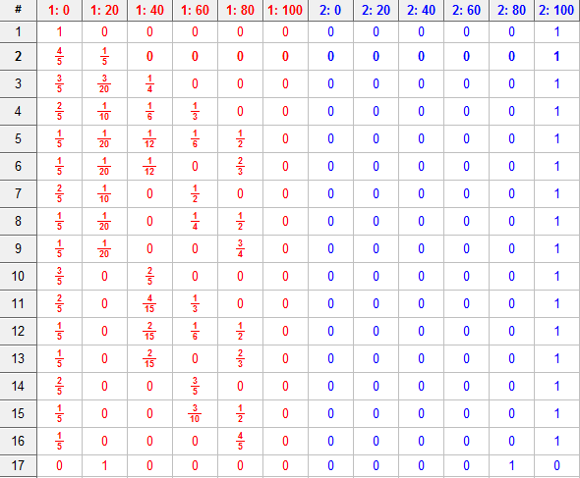

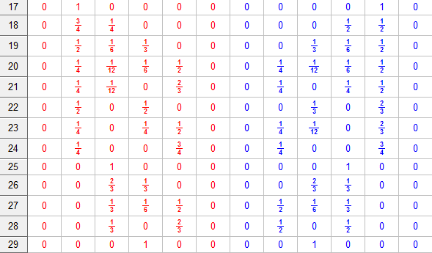

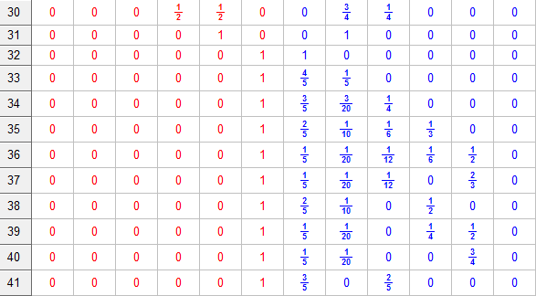

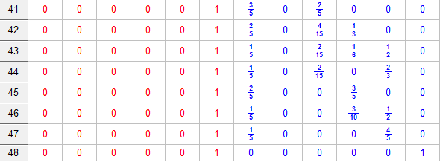

4-

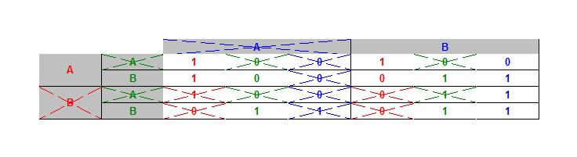

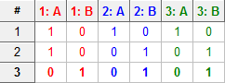

5-

Prob L = p => prob R = 1 – p

E2 (p2 = L) = 2 x p + 0 x (1 – p) = 0 x p + 2 x (1 – p)

2p = 2 – p => p = 1/2

Prob L = q => prob R = 1 – q

E1 (q1 = L) = X x q + 0 x (1 – q) = 0 x q + 2 x (1 – q)

Xq = 2 – q => q = 2/(X+2)

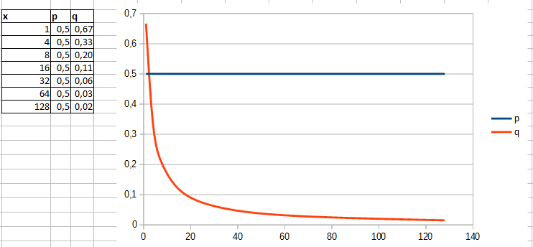

6-

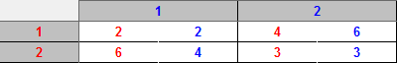

6.png

7-

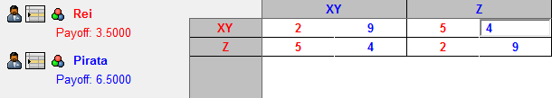

11.png

8-

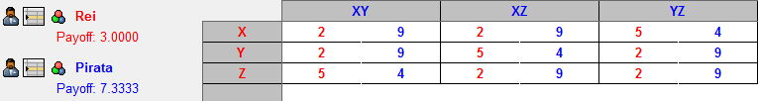

10.png